
PHILIPPINE GENERAL HOSPITAL
OUT PATIENT DEPARTMENT
SECTION OF ALLERGY AND IMMUNOLOGY

Atopic Dermatitis
Follow up Form

PERSONAL DATA
Patient’s Name _______________________________________________________ Case No ________________
Age ______ Sex ______ Status _______ Date Data was Taken_____________________
Birthday _______________________ Birthplace ______________________________
Address ________________________________________________________________ Contact No ______________
Source of Referral ___________________________ Informant _________________________ Reliability _______%
----------------------------------------------------------------------------------------------------------------------------------------------------------------

SCORAD(European Task Force on Atopic Dermatitis)

Topical Steroid Used:
Potency(brand name):
Amount/Month:
Number of flares/month:

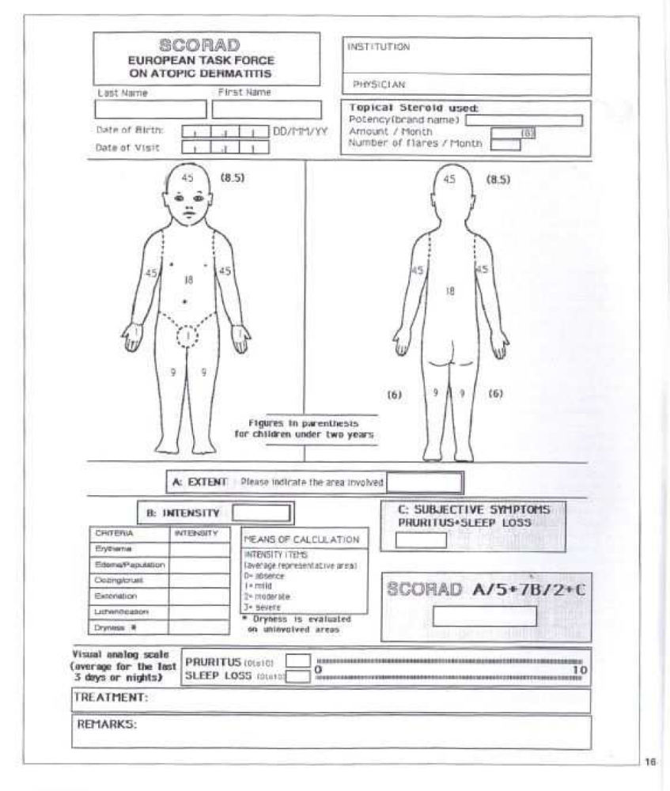
Figures in parenthesis for children under two years old

A: Extent: please indicate the area involved: #

B: Intensity:
Criteria | Intensity (0-3)
Erythema
Edema/papule
Scabs/oozing
Excoriation
Lichenification
Skin dryness*
Means of calculation
Intensity Items (average representative areas)
0: absent
1: mild
2: moderate
3: severe
*dryness is evaluated on uninvolved areas\

C: Subjective Symptoms
Pruritus*Sleep Loss #

Visual Analogue Scale (average for the last 3 days or nights)

Pruritus(0 t0 10 ) # 0----------------------------------------------------------------10

Sleep loss (0-10) # 0----------------------------------------------------------------10

SCORAD: A/5 + 7B/2 + C #

TREATMENT:
REMARKS:

Examined by: _______________________

(Signature over printed name)

Institution:

SCORAD:
Mild atopic dermatitis: few inflammatory flare-ups, SCORAD below 20
Moderate atopic dermatitis: intense inflammation and pruritus, SCORAD between 20-40
Severe atopic dermatitis: extensive, inflammatory, with frequent flare-ups, SCORAD above 40

PHILIPPINE GENERAL HOSPITAL
OUT PATIENT DEPARTMENT
SECTION OF ALLERGY AND IMMUNOLOGY

APAS FORM
Follow up Form
Patient’s Name _______________________________________ Case No _____________________
Age ____ Sex ____ LMP (If pregnant) ______________
Basis of APAS Dx _________________________________________________________________________________

Date of consult
Last seen in clinic
AOG by LMP
AOG by 1st UTZ
Last working impression

Medications | [ ] ASA  [ ] Heparin  [ ] Coumadin  [ ] Others | [ ] ASA  [ ] Heparin  [ ] Coumadin  [ ] Others
Review of systems | Headache / blurring of vision  Photosensitivity / malar rash / oral ulcers  Paroxysmal dyspnea / chest pain  Abdominal pain / contractions / bleeding  Skin mottling / joint pain / swelling  Bruisabiltiy / claudication / paresthesia  Others: | Headache / blurring of vision  Photosensitivity / malar rash / oral ulcers  Paroxysmal dyspnea / chest pain  Abdominal pain / contractions / bleeding  Skin mottling / joint pain / swelling  Bruisabiltiy / claudication / paresthesia  Others:
Latest laboratory results
UTZ
Fetal weight
Placenta
Presentation
AFI / volume
Doppler
Uterine (N) L/R
Umbilical (N) L/R
BPP
PHYSICAL EXAMINATION
HT / WT
BP / HR / RR
General
Head/face/hair | Alopecia / malar rash / discoid rash | Alopecia / malar rash / discoid rash
Eyes | Conjunctivae: pink / pale  Sclerae: anicteric / icteric | Conjunctivae: pink / pale  Sclerae: anicteric / icteric
Ears
Nose
Oral cavity
Throat
Neck, thyroid | Normal / thyromegaly | Normal / thyromegaly
Lymph nodes | Normal / enlarged | Normal / enlarged
Chest and lungs | Equal chest expansion / clear breath sounds / rales / wheeze | Equal chest expansion / clear breath sounds / rales / wheeze
Heart | Regular rhythm / murmur | Regular rhythm / murmur
Abdomen | Normal / hepatomegaly / splenomegaly / mass / tender | Normal / hepatomegaly / splenomegaly / mass / tender
Extremities | Pink / pale / cyanotic / gangrene / warm / cold / edema / joint swelling | Pink / pale / cyanotic / gangrene / warm / cold / edema / joint swelling
Pulses | Full / equal / weak / absent | Full / equal / weak / absent
Skin | Normal / livedo reticularis | Normal / livedo reticularis
Neurologic | GCS: E__V__M__  Cranial nerves: Intact / Abnormal ___________  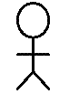  Motor: Normal (5/5)  1/5, 2/5, 3/5, 4/5  Sensory: Normal  ___% Deficit  Meningeals: Supple neck  Kernig’s / Brudzinski  Autonomics: Normal / Abnormal | GCS: E__V__M__  Cranial nerves: Intact / Abnormal ___________  Motor: Normal (5/5)  1/5, 2/5, 3/5, 4/5  Sensory: Normal  ___% Deficit  Meningeals: Supple neck  Kernig’s / Brudzinski  Autonomics: Normal / Abnormal
Present working impression

Diagnostics

Therapeutics | [ ] ASA  [ ] Heparin  [ ] Coumadin  [ ] Others | [ ] ASA  [ ] Heparin  [ ] Coumadin  [ ] Others
Referrals

Next ffup on
Examined by

